# ..\..\Bilder\LOGO\Kunststoffe\KURO_Logo.gif

###### KURO – Information for invitation to tender

**Product:**

#### PVC T-piece and cross-piece

# Information for invitation to tender:

**Ein Bild, das Entwurf, Diagramm, technische Zeichnung, Zeichnung enthält.
**

|  |  |
| --- | --- |
| Pos:....................... | PVC T-Piece (Cube)  Cube: 200 x 200 x 200 mm |
|  | Leavings: 3x 110x3,2 mm (with integral seal socket)  Colour: black/grey |
|  | System KURO o. glw. (www.kuro-kunststoffe.de), |
|  | supply and install, as an addition to pos: ........... |
|  |  |
|  | Amount:............Pieces UP: ....... TP: ........ |

**Ein Bild, das Entwurf, Diagramm, technische Zeichnung, Plan enthält.
**

**Ein Bild, das Diagramm, Reihe, Entwurf, Symmetrie enthält.
**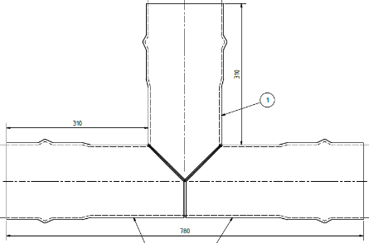

|  |  |
| --- | --- |
| Pos:....................... | PVC Kreuzungspiece (Cube)  Cube: 200 x 200 x 200 mm |
|  | Leavings: 4x 110x3,2 mm (with integral seal socket)  Colour: black/grey |
|  | System KURO o. glw. (www.kuro-kunststoffe.de), |
|  | supply and install, as an addition to pos: ........... |
|  |  |
|  | Amount:............Pieces UP: ....... TP: ........ |
| Pos:....................... | PVC T-Piece  Dimension: 110 x 3,2 mm |
|  | Leaving: 110 x 3,2 mm / Seal: 3 x integral seal socket  Colour: black/grey |
|  | System KURO o. glw. (www.kuro-kunststoffe.de), |
|  | supply and install, as an addition to pos: ........... |
|  |  |
|  | Amount:............Pieces UP: ....... TP: ........ |
| Pos:....................... | PVC Kreuzungspiece  Dimension: 110 x 3,2 mm / Seal: 3 x integral seal socket |
|  | Colour: black/grey |
|  | System KURO o. glw. (www.kuro-kunststoffe.de), |
|  | supply and install, as an addition to pos: ........... |
|  |  |
|  | Amount:............Pieces UP: ....... TP: ........ |